**UpWork - Job Description (CSS only)**

**Some background regarding the project**:

Basically **I only care about the screen size for mobile size**, which I’ve defined as:

@media screen and (max-width: 480px) {

…

…

…

}

So if you open the source code in “desktop” / “tablet” mode? => you’ll see everything is scrambled, so don’t try to fix it or something. Simply resize screen width to be less then 480 and you should see the following:

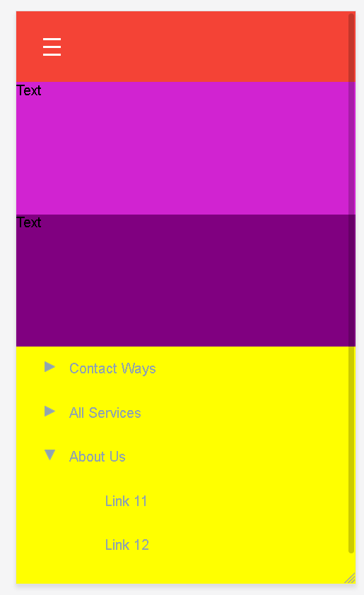

**(more on next page)**

**What actually needed to be done**:

If you look at the picture above, I’ve intentionally put 2 divs between the “menu button” and the actual menu” (ping and purple one), **and they should stay there**.

**Task of this project is the following**:

1. Whenever user clicks on the “Menu button”, the button will be opened on top of the entire screen, but will have margin of 80px from top (which is exactly the size of the red menu bar (header if you wish)). So basically, it would look like this:

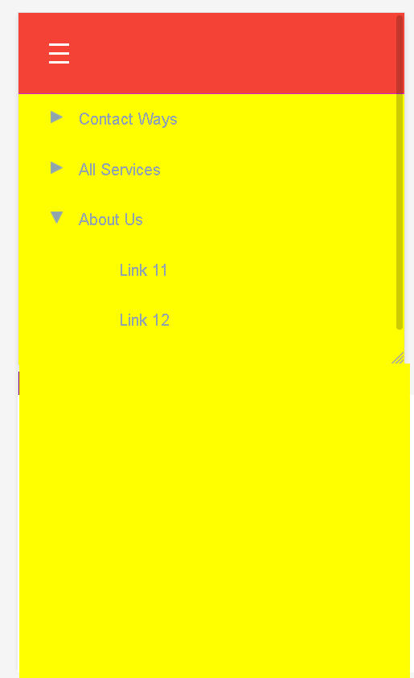

1. The menu that opens up? => should allow the user to scroll all the way to the bottom (end of menu) - still in the “yellow menu window”. If you look closely, I’ve set 25links on the first menu just to check that.
2. HTML should change the way it is. You can add / change classes / id’s but mustn’t change the actual html code. If, from some reason, you need to change / add something in the html, I’ll need to approve it and not sure I’ll do because of SEO formation, but I can always examine the change, and if in my opinion it isn’t that bad - why not.
3. No javascript allowed. CSS only (no problem with SCSS - as long as the fix is done on the .css file).
4. Solution must be cross platform (don’t care about I.e8.. modern browsers only).

**Thank you**.